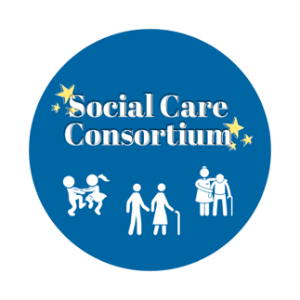

Disclosure and Barring Service (DBS) REQUIREMENTS
Please note that you have to provide original documents listed in group 1 and 2 below, where our staff will take copies and give the original back to you.

If you provide one document from group 1 list, then you need to provide two more from group 2 list.
If you provide two from group 1 list, you need to provide one more from group 2 list.

For those who do not have any from group 1 list, they need to provide any 5 documents from group 2 list.
Utility Bills will require not being more than 3 months old.

GROUP 1
- A Passport
- UK Driving Licence
- Original UK Birth Certificate
- Valid Photo Identity Card (EU Countries)

GROUP 2
- Marriage Certificate
- Non UK Birth Certificate
- P45/P60
- Bank Statement
- Any Utility Bill
- Valid TV Licence
- Credit Statement
- Store Card Statement
- Mortgage Statement
- Valid Insurance Certificate
- Correspondence/document From Benefit Agency, Local Authority, Inland Revenue
- Financial Statement (e.g. Pension. Endowment)
- Valid Vehicle Registration Document
- Mail Order Catalogue Statement
- Court Summons
- Valid NHS Card
- Addressed Payslip
- National Insurance
- Exam Certificate
- Child Benefit Book
- Connexions Card
- Certificate of British Nationality
- Work Permit

You will also have to pay a fee of £54.00.for DBS. Once the application form is sent to the DBS department, it normally takes between 4-6 weeks to process and the certificate will be sent directly to you.

